Contents
I. Game Overview 1
II. Game Play Mechanics 2
III. Controls 3
IV. Saving and Loading 4
V. Menus and Screen Descriptions 5
VI. Game World 6
VII. Levels 7
VIII. Characters 8
IX. Non-player Characters 9
X. Enemies 10
XI. Weapons 11
XII. Items 12
XIII. Abilities 13
XIV. Vehicles 14
XV. Scripts Title Name 15
XVI. Scoring 16
XVII. Puzzle / Mini Games 17
XVIII. Bonuses 18
XIX. Cheat Codes 19
XX. Future Features 20

I. Game Overview
Night of the Living Chud is a first-person horror game set in a dark forest environment. The player explores the map to collect six missing person photographs while being hunted by a mysterious creature.
The goal of the game is to collect all six photos and survive. The player wins once all photos are collected. The player loses if the enemy catches them.

II. Game Play Mechanics
The gameplay focuses on exploration, tension, and survival. The player navigates through a foggy forest searching for hidden photos while avoiding the enemy.
As the player collects photos:
The enemy becomes more aggressive
The tension increases
The player must rely on movement and awareness
The enemy uses a stalking system:
Appears near the player when not being watched
Stares at the player before moving
Teleports around the environment
Eventually begins chasing the player directly

III. Controls
W → Move forward
A → Move left
S → Move backward
D → Move right
Mouse → Look around
Shift → Sprint (uses stamina)
F → Toggle flashlight
E → Interact / close UI
ESC → Pause

IV. Saving and Loading
The game does not include a save or load system. Each playthrough is completed in one session.

V. Menus and Screen Descriptions
Main Menu
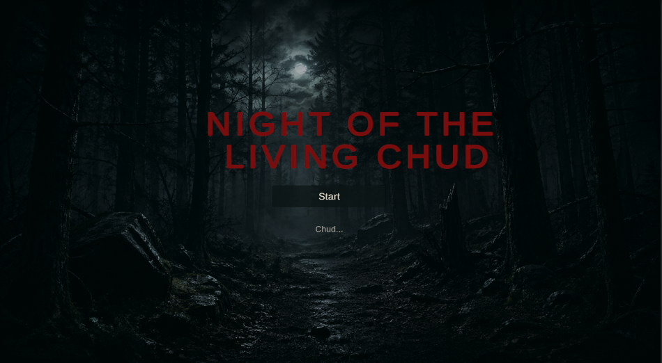
Displays game title and start button
Pause Menu
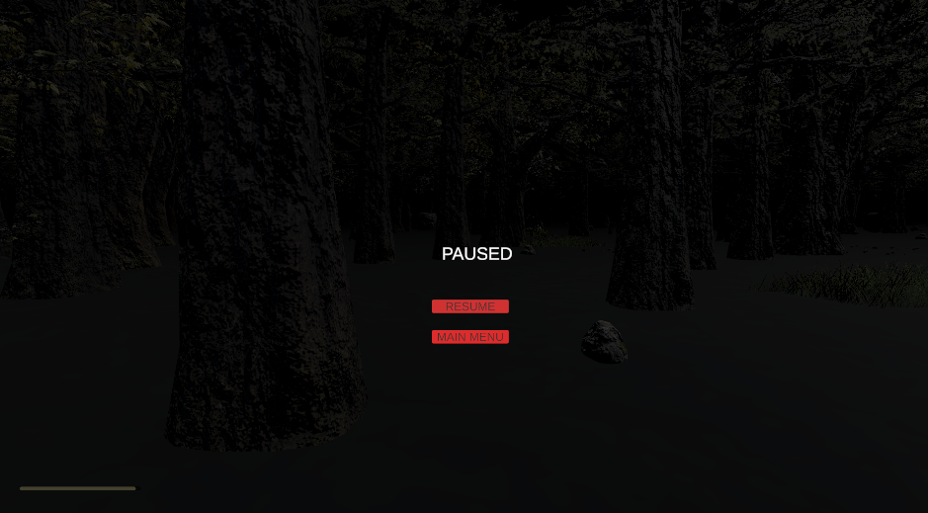
Resume game
Return to main menu
Win Screen
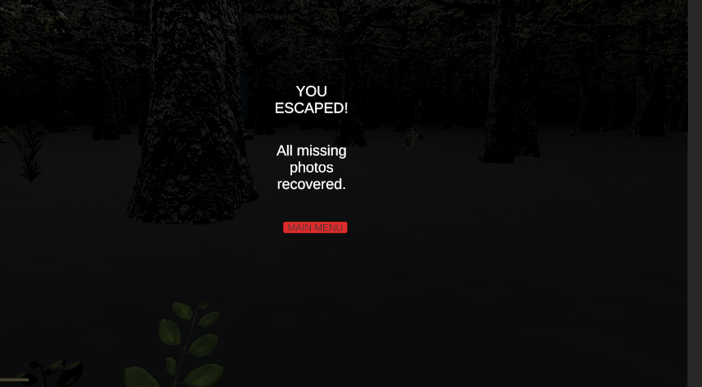
Appears after collecting all photos
Game Over Screen

Appears when the player is caught
Photo Inspection Screen 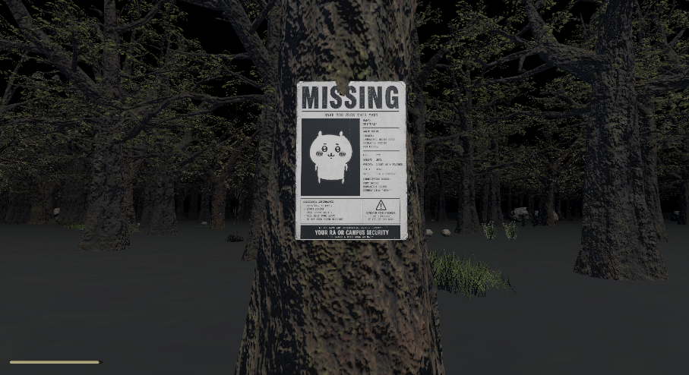
Shows a zoomed-in version of collected photos
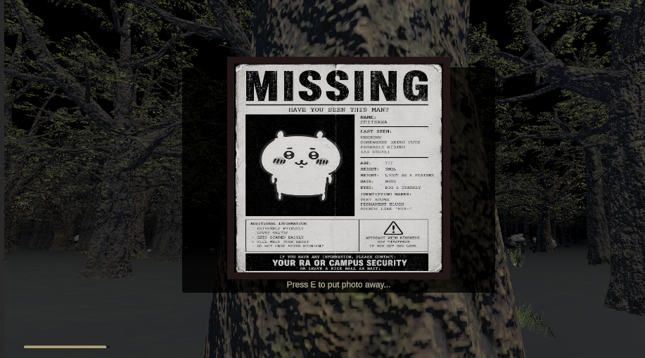

VI. Game World
The game takes place in a dark forest environment featuring:
Dense tree clusters
Cemetery-style stone walls
Fog and low visibility
Minimal lighting for atmosphere
The world is designed to feel isolated and unsettling.
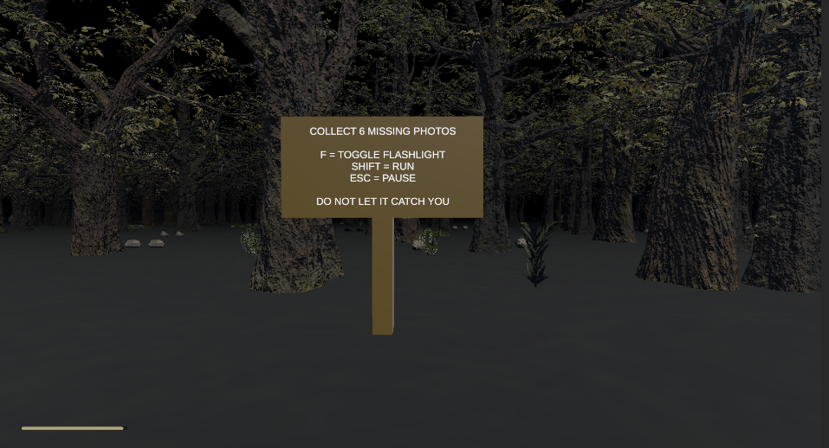

VII. Levels
The game consists of a single level. Difficulty increases dynamically as the player collects more photos.

VIII. Characters
Player
First-person character
Can move, sprint, and interact
Limited stamina system

IX. Non-player Characters
The game includes a tutorial sign that explains controls and objectives to the player at the start of the game.


X. Enemies
The Chud (Spider Variant)
Multi-headed spider-like creature
Uses stalking and teleportation behavior
Becomes more aggressive as the player progresses
Behavior progression:
Early game: watches and stalks
Mid game: teleports and pressures the player
Late game: aggressively chases

XI. Weapons
The player has no weapons. The game focuses on survival and avoidance.

XII. Items
Missing Person Photos
Main objective items
Trigger enemy behavior changes

XIII. Abilities
Sprinting (limited by stamina)
Flashlight usage

XIV. Vehicles
None.

XV. Scripts Title Name
GameManager.cs
EnemyChase.cs
PlayerMovement.cs
FlashlightToggle.cs
FlashlightFlicker.cs
HeartbeatController.cs
CollectiblePage.cs
SignInspect.cs
SpiderWiggle.cs

XVI. Scoring
There is no scoring system. Progress is tracked by collected photos.

XVII. Puzzle / Mini Games
No traditional puzzles. The challenge comes from exploration and survival.

XVIII. Bonuses
No bonus system is currently implemented.

XIX. Cheat Codes
No cheat codes are included.

XX. Future Features
Improved enemy AI
More environmental detail (grass, rocks, props)
Enhanced sound design (ambient sounds, footsteps)
Additional enemy types
Expanded map or multiple levels
Save/load system
More scripted horror events

